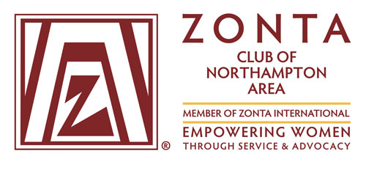
Attn: Audrey Millgate, Club Treasurer
audreymillgate@gail.com or mail to:
430 E 6th St 11H New York NY 10009.

Membership Application Form

Thank you for adding your voice to empowering women by seeking to join our club and become part of the larger global community of Zonta International. Please complete this form and email or mail to the contact indicated above. You will be contacted by a member of our club for further details.

Member type: ☐ Club Member ☐ Reinstating Member ☐ Young Professional (YP = under 35 years of age)

First Name: ________________________ Last Name: ___________________________________

Residence Address: ____________________________ City: ____________ State ______ Zip _______

Phone Number _____________________________ E-mail: __________________________________

Gender: ☐ Female ☐ Male ☐ Other Date of birth (required for YP rate): Click or tap here to enter text.

Please contact me by: ☐ Phone ☐ E-mail The best time to talk: ☐ AM ☐ Afternoon ☐ Evening

I am active or have been previously active in a business or profession: ☐ Yes ☐ No
Specific knowledge/skills I can contribute to the club and its work in the community include:
Click or tap here to enter text.

I will commit to upholding Zonta’s mission and vision for a more equal world, which drives global and local service and advocacy efforts. ☐ Yes ☐ No

I am willing to contribute financially to and raise money for local & international projects that benefit women: ☐ Yes ☐ No

Why are you interested in joining our club? What would you like to get back in return?
Click or tap here to enter text.

How did you hear about Zonta? Click or tap here to enter text.

Signature _______________________________ Date __________________________________

